­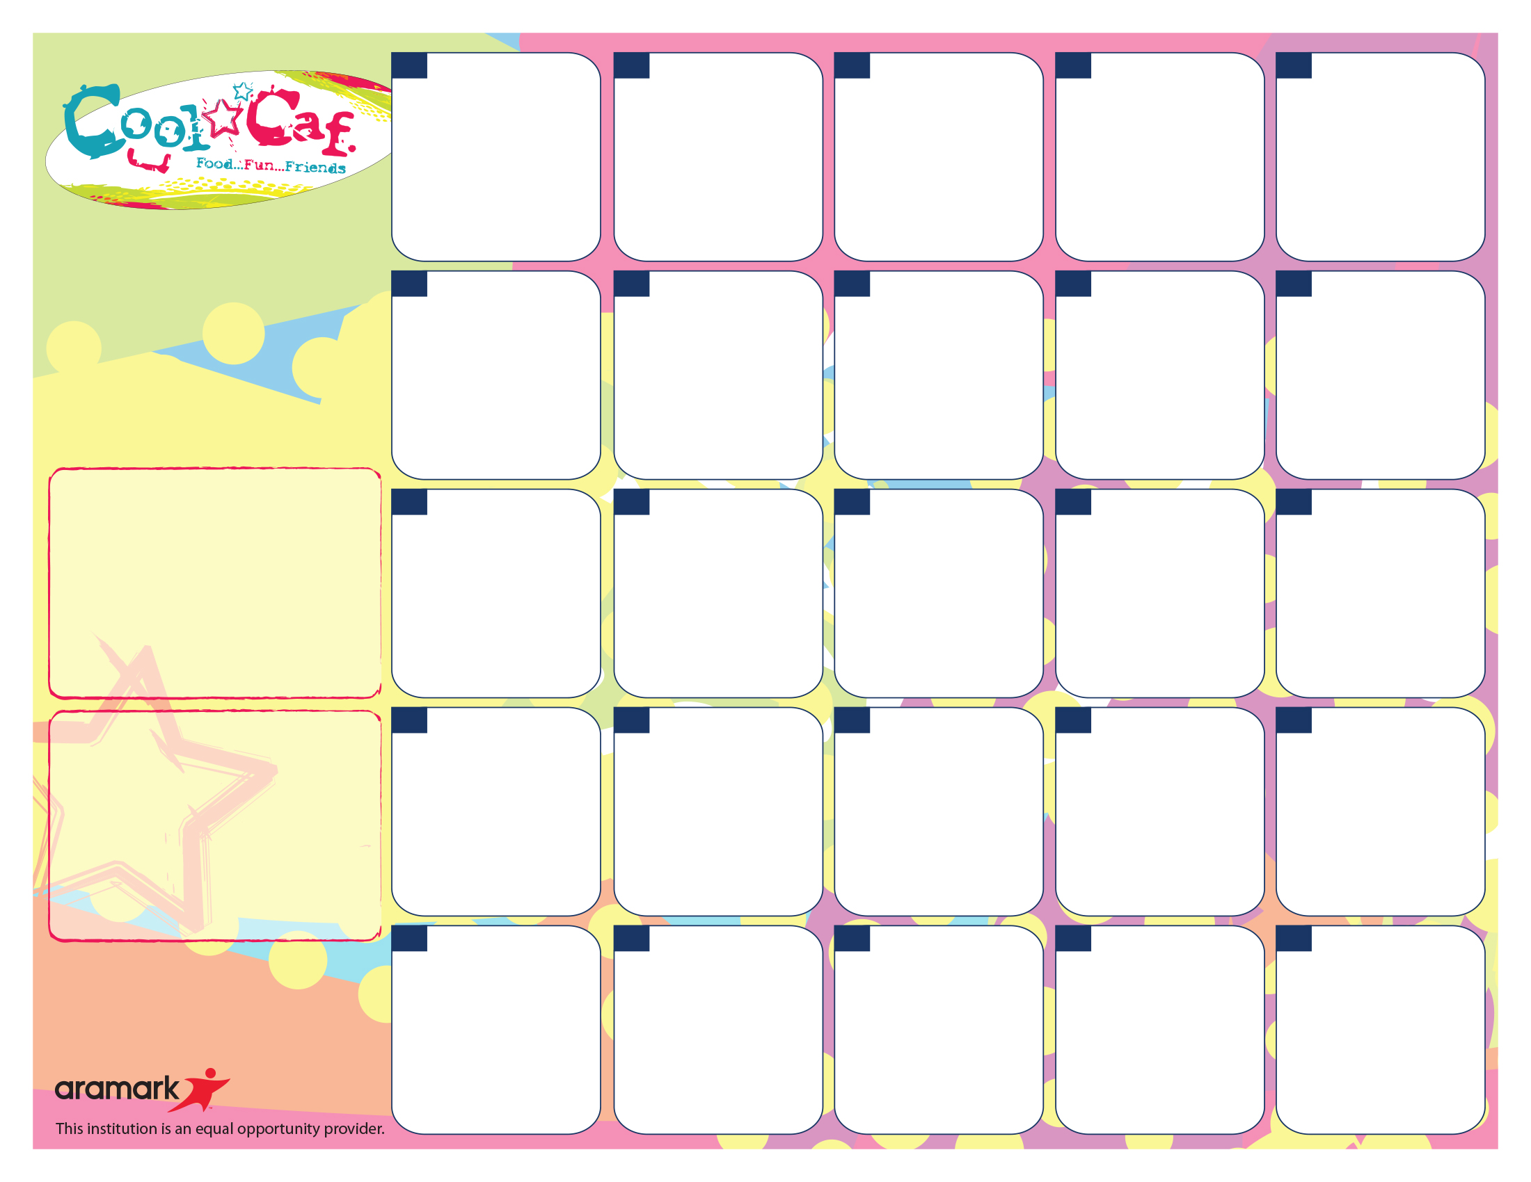

***September Fun Facts***

*National Potato Month

*First Teddy Bear made in 1902

*Sept. 19 – *International Talk Like A Pirate Day*

*Sept. 22 - First day of Fall

*First Newspaper printed in US was Sept. 25, 1690

*September is known as Harvest Month

Thurs. Sept. 19 – SCHOOL PICTURE DAY

Thurs. Sept. 19 – Mid-Quarter

Fri., Sept. 20 – NO SCHOOL – PD day

Sept. 30 – Oct. 4 – BOOK FAIR

Thurs. Oct. 3 – FAMILY READING NIGHT

Cheeseburger*

Wedge Fries

Carrot Sticks

Ketchup & Ranch

100% Fruit Juice

Milk Choice

**11**

Mozzarella Sticks*

With Italian Sauce

Broccoli

FF Ranch

100% Fruit Juice

Milk Choice

**8**

Cheese Quesadilla

Taco Sauce

Broccoli

100% Fruit Juice

Milk Choice

**4**

Chinese Sweet/Fried Chicken

Brown Rice*

Fresh Celery Sticks FF Ranch

100% Fruit Juice

Milk Choice

**3**

Chicken Tenders*

Ketchup

Wedge Fries

Fresh Carrot

FF Ranch

100% Fruit Juice

Milk Choice

**2**

Pizza*

Pinto Beans

Salad

FF French

100% Fruit Juice

Milk Choice

**1**

Buffalo Chicken Wrap

Celery

FF Ranch Dressing

100% Fruit Juice

Milk Choice

**26**

Hamburger*

Mac & Cheese*

Ketchup/Mustard

Carrot Sticks

100% Fruit Juice

Milk Choice

**25**

Popcorn Chicken*

Wedge Fries

Ketchup

Fresh Broccoli

FF Ranch

100% Fruit Juice

Milk Choice

**24**

Taco

Lettuce

Pinto Beans

Taco Sauce

100% Fruit Juice

Milk Choice



**23**

Turkey Sandwich*

Fresh Broccoli

FF Ranch

Goldfish

Mustard

100% Fruit Juice

Milk Choice

**19**

Pizza Bosco Sticks*

Fresh Celery

FF Ranch

100% Fruit Juice

Milk Choice

**18**

Tex-Mex Nachos*

Taco meat

Cheese Sauce

Lettuce

Pinto Beans

100% Fruit Juice

Milk Choice



**16**

**THURS. BREAKFAST**

Surprise Breakfast

Banana

100 % Fruit Juice

Milk Choice

**NO SCHOOL!**

**TEACHER WORK DAY!**

**20**

**17**

Chicken Patty*

Mac & Cheese*

Carrots

100% Fruit Juice

Milk Choice

Hot Dog*

Ketchup/Mustard

Baked Beans

100% Fruit Juice

Milk Choice

**7**

Chicken Nuggets*

BQ sauce

Green Beans

100% Fruit Juice

Milk Choice

**30**

Corn Dog*

Ketchup

Green Beans

100% Fruit Juice

Milk Choice

**27**

Mini Corn Dogs*

Ketchup

Mixed Vegetables

100% Fruit Juice

Milk Choice

**10**

Sloppy Joe*

Carrots

100% Fruit Juice

Milk Choice

**9**

**MON. BREAKFAST**

WG Cinnamon Toast Crunch

Applesauce

100 % Fruit Juice

Milk Choice

**FRI. BREAKFAST**

WG Coco Puffs

Banana

100% Fruit Juice

Milk Choice

**WED. BREAKFAST**

WG Pop Trat

Strawberry Banana Yogurt

Fruit

100 % Fruit Juice

Milk Choice

**TUES. BREAKFAST**

WG Mini Bagel/Cream cheese filling

Apple

100 % Juice

Milk Choice

**Sept 16 – Oct. 11 2024**

*Whole Grain product