­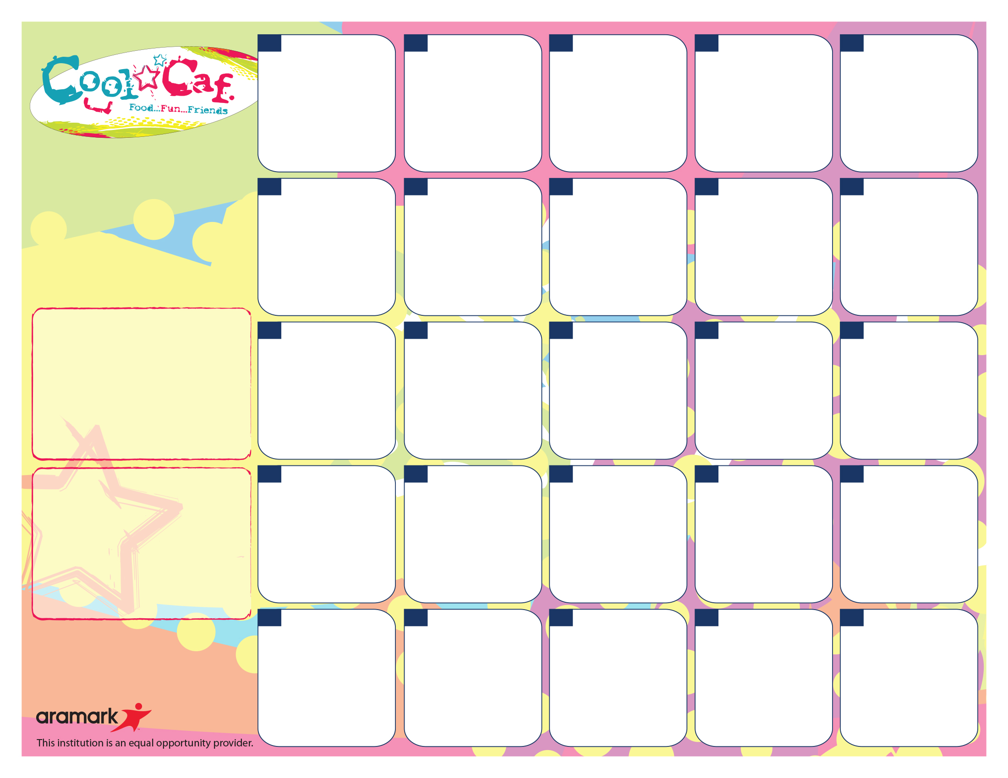

Cheese Quesadilla

Taco Sauce

Broccoli

100% Fruit Juice

Milk Choice

**1**

Chinese Sweet Fried

Brown Rice* with Chicken

Fresh Celery Sticks FF Ranch

100% Fruit Juice

Milk Choice

**31**

Chicken Tenders*

Ketchup

Wedge Fries

Fresh Carrot

FF Ranch

100% Fruit Juice

Milk Choice

**30**

Pizza*

Pinto Beans

Salad

FF French

100% Fruit Juice

Milk Choice

**29**

Hamburger*

Mac & Cheese*

Ketchup & Mustard

Carrot Sticks

100% Fruit Juice

Milk Choice

**23**

Popcorn Chicken*

Wedge Fries

Ketchup

Fresh Broccoli

FF Ranch

100%Fruit Juice

Milk Choice

**22**

Tex Mex Taco with

Lettuce

Pinto Beans

Taco Sauce

100% Fruit Juice

Milk Choice



**21**

Pizza Bosco Sticks*

Fresh Celery

FF Ranch

100% Fruit Juice

Milk Choice

**16**

Chicken Patty*

With Mac & Cheese*

Carrots

100% Fruit Juice

Milk Choice

Mozzarella Sticks* with Italian Sauce

Broccoli

FF Ranch

100% Fruit Juice

Milk Choice

**5**

Mini Corn Dogs*

Ketchup

Mixed Vegetables

100% Fruit Juice

Milk Choice

**7**

Cheeseburger with

Whole Grain Bun*

Wedge Fries

Carrot Sticks

Ketchup & Ranch

100% Fruit Juice

Milk Choice

**8**

Beef Hot Dog w/ Bun*

Ketchup & Mustard

Baked Beans

100% Fruit Juice

Milk Choice

**4**

Buffalo Chicken Wrap

Celery

FF Ranch Dressing

100% Fruit Juice

Milk Choice

**24**

Turkey Sandwich*

Fresh Broccoli

FF Ranch

Goldfish Crackers

Mustard

100% Fruit Juice

Milk Choice

**17**

**TUES. BREAKFAST**

WG Mini Bagel w/ Cream cheese filling

Apple

100% Fruit Juice

Milk Choice

**MON. BREAKFAST**

WG Cinnamon Toast Crunch

Applesauce

100% Fruit Juice

Milk Choice

**HALLOWEEN FUN FACTS**

*Candy Corn has been around since the 1880’s and originally called chicken feed

*Reese Peanut Butter Cups are the #1 selling Halloween Candy

*Japan has over 350 flavors of KitKats

*Twizzlers were invented in 1845

*In 2012, the World’s Largest Lollipop weighed 7,003 pounds

**OCTOBER FUN FACTS**

*Statue of Liberty dedication on Oct. 28, 1886

*World Series began Oct. 1, 1903

*Walt Disney World opened

Oct. 1, 1971

*Every 19yrs, there is a full moon on Halloween

*Illinois produces twice as many pumpkins as any other state

Tex-Mex Nachos*

Taco Meat

Cheese Sauce

Lettuce

Pinto Beans

100% Fruit Juice

Milk Choice



**14**

**NO SCHOOL!**

**TEACHER WORK DAY!**

**18**

**THURS. BREAKFAST**

Surprise Breakfast

Banana

100% Fruit Juice

Milk Choice

**15**

Chicken Nuggets*

BBQ Sauce

Green Beans

100% Fruit Juice

Milk Choice

**28**

Corn Dog*

Ketchup

Green Beans

100% Fruit Juice

Milk Choice

**25**

Sloppy Joe on Whole Grain Bun

Hot Carrots

100% Fruit Juice

Milk Choice

**6**

**FRI. BREAKFAST**

WG Coco Puffs

Banana

100% Fruit Juice

Milk Choice

**WED. BREAKFAST**

WG Pop Trat

Strawberry Banana Yogurt

Fruit

100% Fruit Juice

Milk Choice

SunBridge Schools

Oct. 14 – Nov. 8, 2024

Friday, Oct. 18 – NO SCHOOL

**\*Whole Grain Product**